DriverPass System Design Document
CS 255 | Project Two | Drew Trembley
Design basis: DriverPass Project One Business Requirements and Model Application Paper. The five diagrams below describe the proposed system, not an implemented product.

UML Diagrams

UML Use Case Diagram
The system boundary includes customer enrollment, reservations, online learning, driver lesson records, package and report administration, account management, and DMV updates. The customer and secretary both use reservations, while owner and IT responsibilities remain separate.
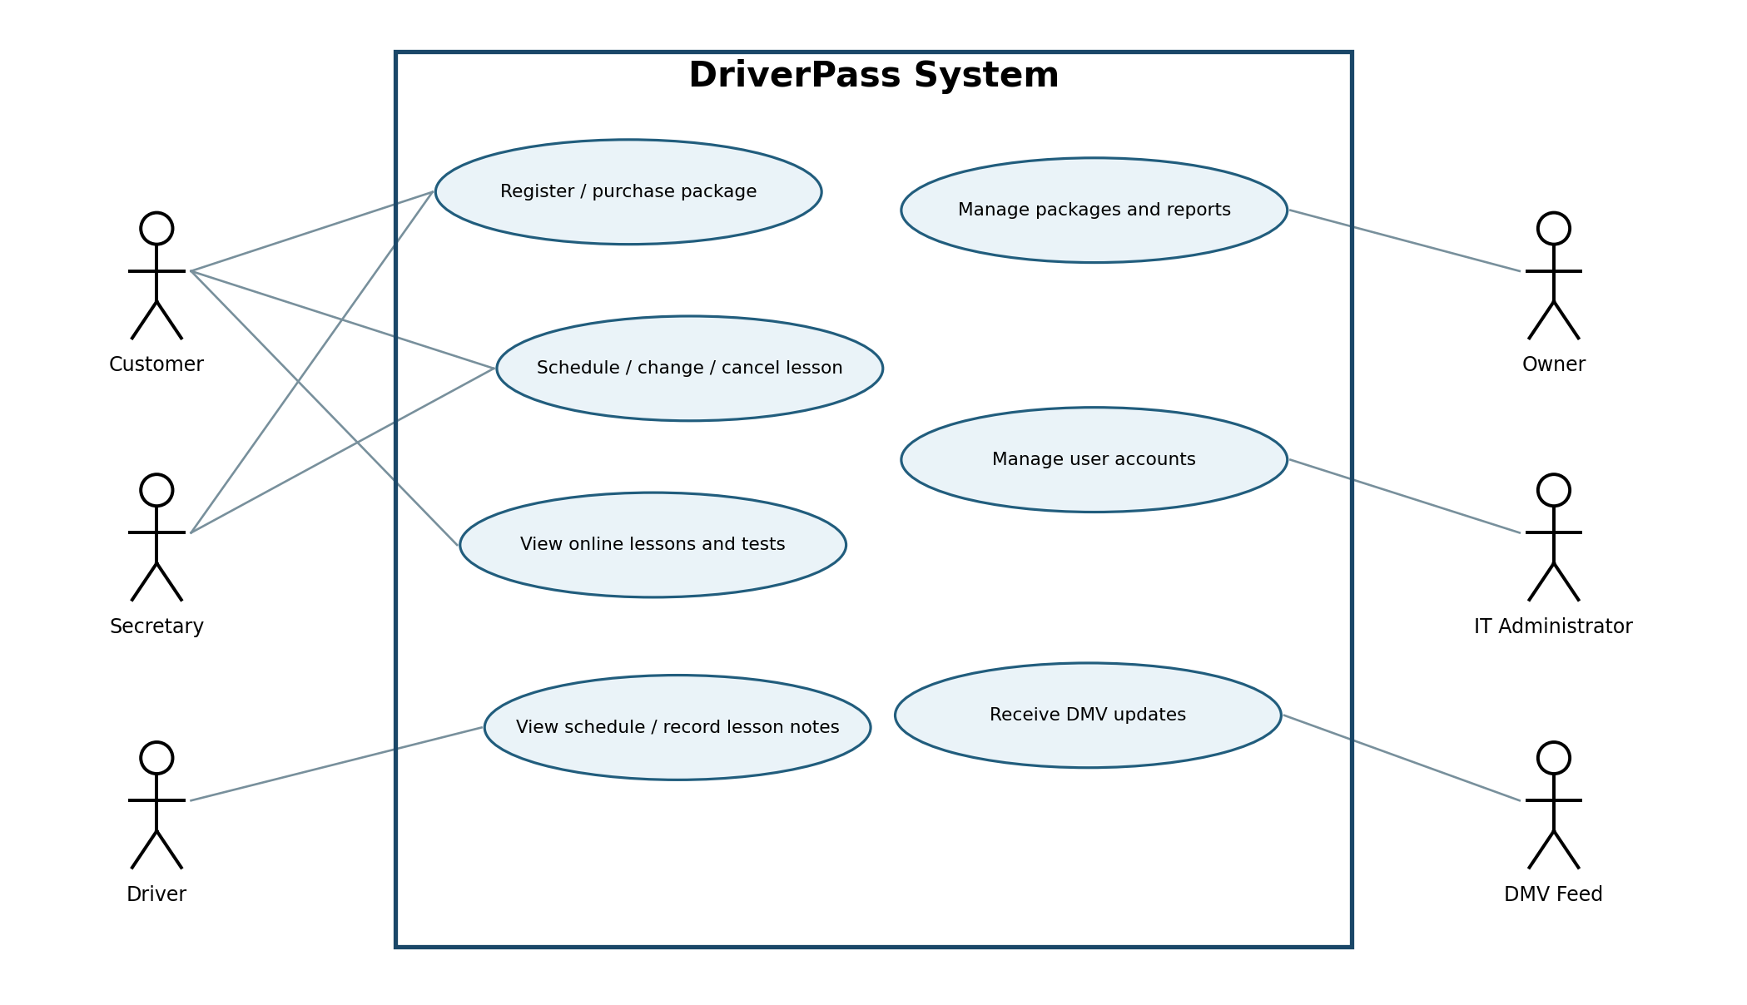

UML Activity Diagram 1: Book Driving Lesson
A reservation is accepted only when the package has sufficient remaining hours and a driver and car are available for the complete two-hour slot. Successful booking saves the reservation and records the responsible user and timestamp. Unavailable slots or insufficient hours return a clear message.
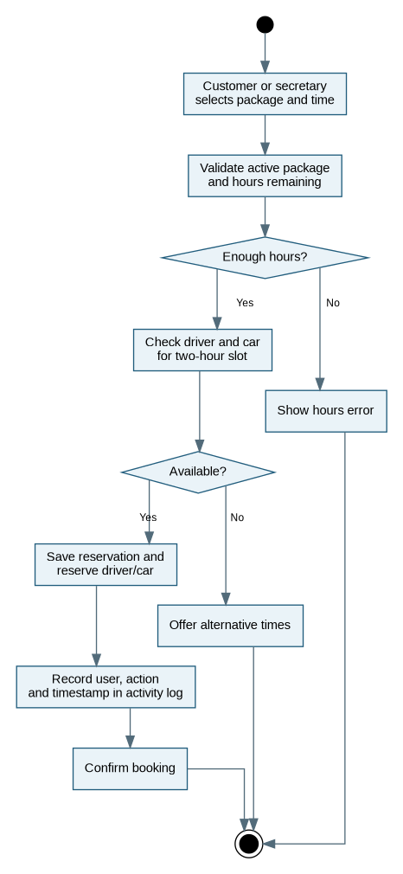

UML Activity Diagram 2: Complete Practice Test
Online tests are restricted to eligible Package Three customers. After a test, the platform records test name, time taken, score, and progress status. Other customers receive an access message rather than access to restricted content.
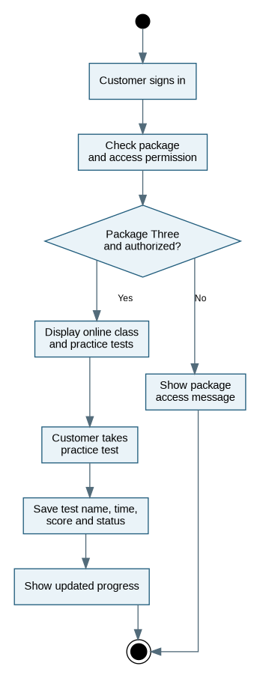

UML Sequence Diagram: Book Driving Lesson
The interaction begins at the browser, validates remaining package hours, checks calendar availability, commits a reservation, and writes an activity entry. The save operation must be atomic, so concurrent requests cannot assign the same car or driver to overlapping lessons.
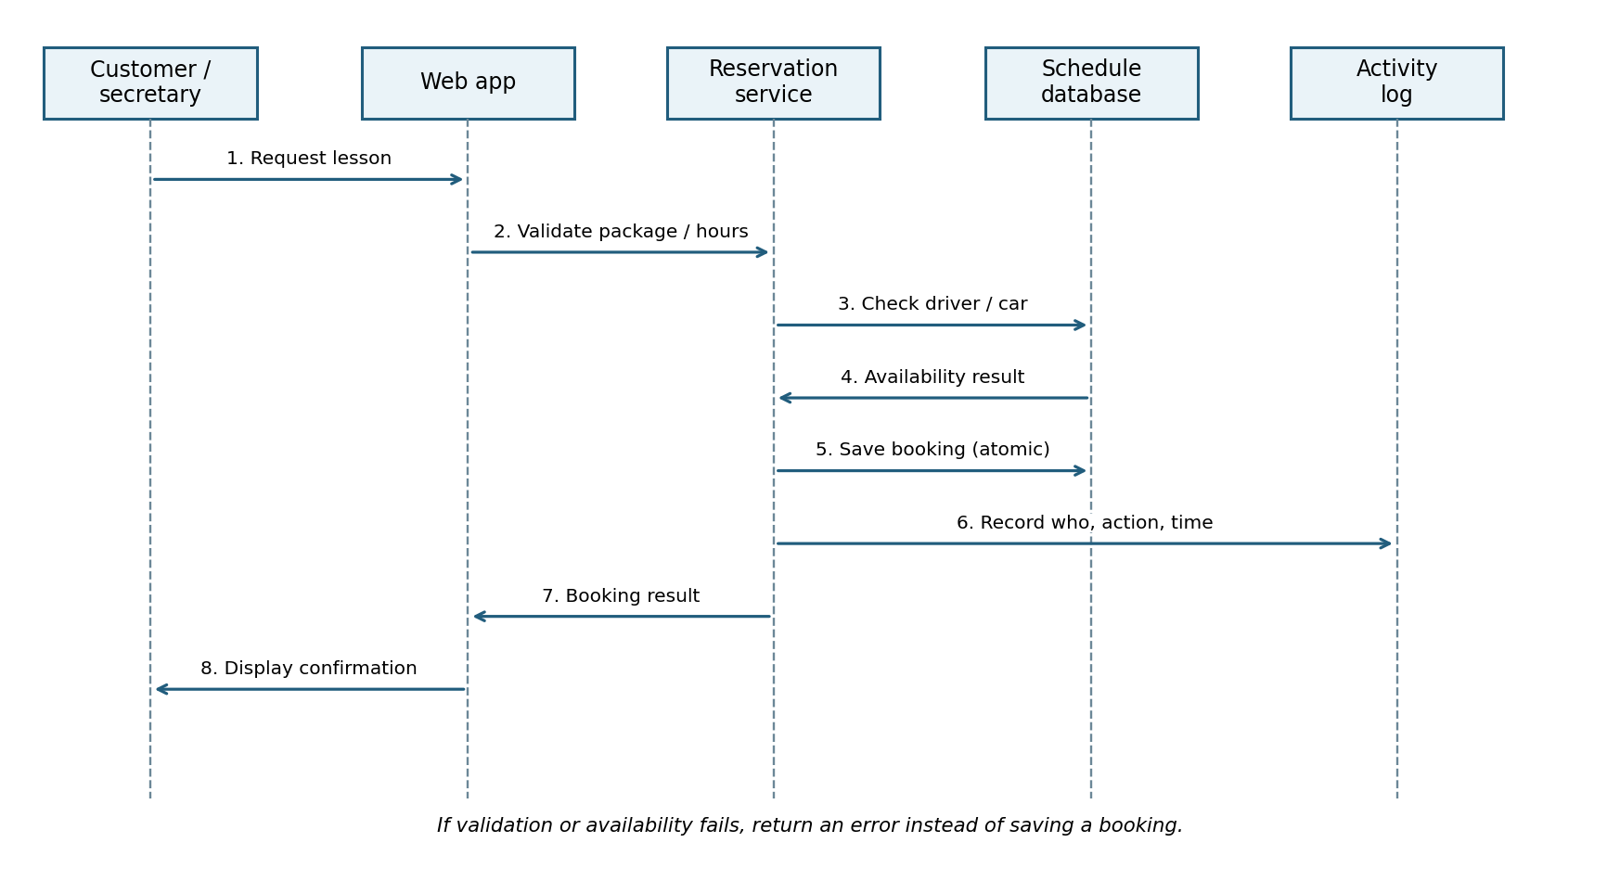

UML Class Diagram
User provides shared authentication data, while Customer and Driver represent specialized users. Reservation links a customer, driver, and car; packages govern entitlements; TestResult, DriverNote, and ActivityLog hold progress, lesson details, and booking accountability. Secretary, Owner, and IT administrator permissions are represented by the User role field.
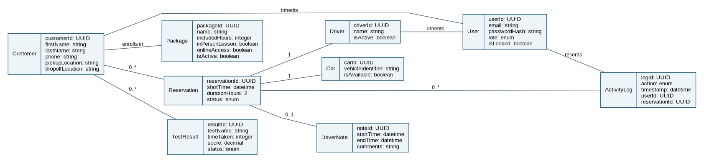

Technical Requirements

Hardware and user devices
A current desktop, laptop, tablet, or smartphone with a modern web browser and internet connection. Employees need office workstations; drivers can use browser-capable mobile devices. No on-premises application server is required.

Application software
A responsive browser-based customer and employee application, backend services for account control, package enrollment, scheduling, learning content, testing, DMV updates and reports; secure interfaces to a payment processor.

Database and integrity
A managed relational cloud database for users, packages, reservations, cars, drivers, test results, driver notes, and audit logs. Use transactional saves and overlap checks to prevent double-booking. Preserve historical reservation events even when reservations are canceled.

Infrastructure
Cloud-hosted web and application services, managed database, HTTPS/TLS certificates, monitored service health, automated backups and recovery tests, scalable capacity, and update deployment during low-traffic periods.

Security
Role-based access for customer, secretary, driver, owner, and IT administrator; encrypted communications and storage; hashed passwords; five-attempt temporary lockout, email password reset, inactive-session timeout, and timely employee deactivation. Payment card credentials must be handled by an external PCI-compliant processor, not stored as plaintext.

Performance and compatibility
Target approximately three seconds for normal page and reservation actions. Reflect confirmed schedule changes immediately. Support current browsers on Windows, macOS, iOS, and Android. Changes require network connectivity, even if previously downloaded reports can be viewed offline.

External integrations and reporting
Use an authorized DMV API/feed if available; notify staff when new questions, policies, or rules arrive. Generate printable activity reports and Excel-compatible exports; alert administrators to failed payments, repeated failed sign-ins, and system errors.

Implementation tools and validation
Use Lucidchart or comparable CASE tooling to maintain diagrams, source control for application code, automated tests for scheduling conflicts and role authorization, and staging review with DriverPass stakeholders before deployment.

Assumptions and boundaries
DriverPass supplies course/test content. Initial operations cover ten driver-and-car assignments and three defined packages. The owner can deactivate a package, but designing entirely new package types is a future development task. DMV integration is conditional on feed availability.

